If one of the computers fails, the whole network will be affected.
If we remove computer from the network, it won’t affect the other computers.
If the main cable fails, the whole network will fail.
If the central server fails, the whole network will fail.
If a cable breaks, the whole network will be affected.
If a computer fails, it won’t affect the other computers.

BUS
STAR
RING | MESH

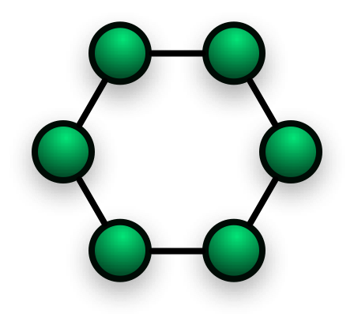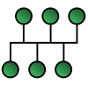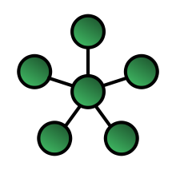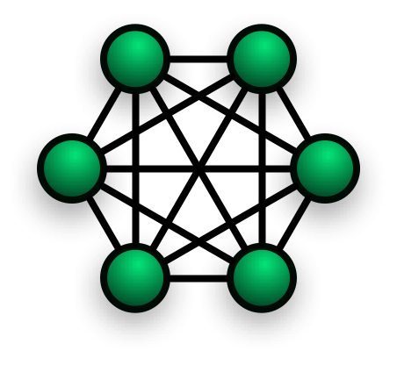

A star topology has a server computer at the centre and a separable cable connecting the server to each of the other computers in the network. The central server controls the flow of data in the network. If the central server fails, the whole network will fail.

In a ring topology, each computer is connected to its neighbouring in a circle. The data flows in one direction round the ring.If a cable breaks or one of the computers fails, the whole network will be affected.

A bus topology has all the computers connected to a common cable. The data travels in both directions along the cable. If a computer fails, or we remove one from the network, it won’t affect the other computers.

